1. **Description**

Nowadays, renting apartment in Phnom Penh starts to increase day by day because of the population. In one apartment normally contains so many rooms which is hard for owner to manage properly. Currently apartment owner uses manual system to track apartment rentals.

These types of recording systems introduce significant risks to the apartment complex

record system such as, misfiling, incorrect entries, and incorrect calculations just to name a few. These mishaps can cost the apartment complex thousands of dollars in lost revenues and wasted time.

The new apartment rental system will greatly simplify the record system used today by allowing owner to focus on managing the apartment complex rather than bookkeeping and record tracking. This system will allow apartment managers to accurately track apartment rentals.

In addition, the system will integrate all components of the apartment rental process to include, deposit tracking, tenant information, apartment unit information, and parking.

1. **Analysis**

1. Person who use system:

⁃ Owner

2. Person who relate with system:

⁃ Tenant (Customer)

⁃ Staff (Security)

Things which relate with system

⁃ Room

3. Requirements of owner toward system

⁃ Manage renting of a tenant such as tenant information, renting period, payment, electricity and water bill.

• Tenant (ID, Name, Gender, DoB, Address, Phone)

• Rental (rentalID, personID, roomID, rentalDate)

• Payment (paymentID, rentalID)

⁃ Manage staff

• Security (ID, Name, Gender, DoB, Address, Phone, Salary)

⁃ Manage Room

• Room (RoomNum, RoomType, Price, Status)

1. **UML Class Diagram**

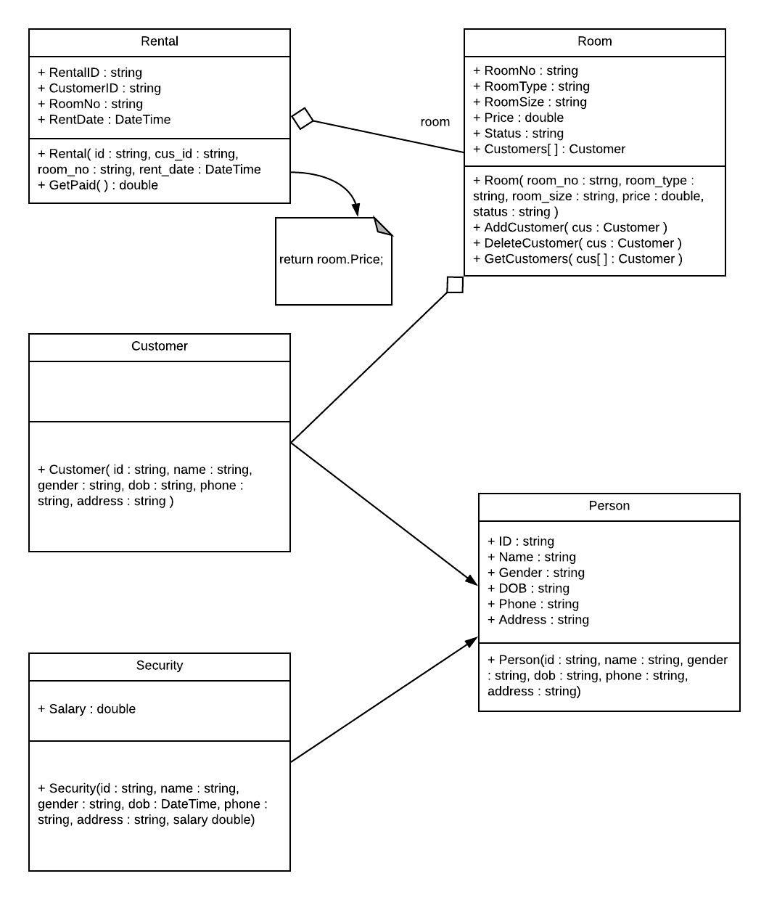

1. **Implementation**

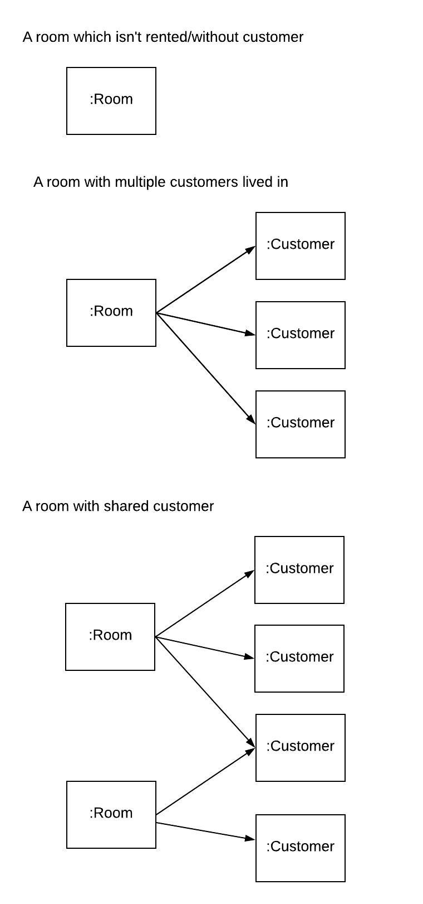

1. **Conclusion**

In the project Room rental management system, what we’ve done were just a part of the whole room rental system which include, some classes that we’ve analyzed such as Customer, room, rental and a type of a worker is Security. However we made this project to be able to scale to be bigger that what we have done, so that future developers could implement to add more functionalities to the project such as add more classes worker like Receptionist, Cashier, Water usage, Electricity usage, Pace for parking vehicle such as bikes, moto-bikes and cars moreover they add new report such as Working history, Rental history, and Customer history which are the important information, so that the owner could review and use some information such reasons of the customers leave that can help them to see if there’re any gaps to fill up and modify their rental services to make the better services for their own business.